Communication

What is Communication?
Communication is simply the act of transferring information from one place, person or group to another.
Every communication involves (at least) one sender, a message and a recipient. This may sound simple, but communication is actually a very complex subject.
The transmission of the message from sender to recipient can be affected by a huge range of things. These include our emotions, the cultural situation, the medium used to communicate, and even our location. The complexity is why good communication skills are considered so desirable by employers around the world: accurate, effective and unambiguous communication is actually extremely hard.

Defining Communication
Communication is more than simply the transmission of information. The term requires an element of success in transmitting or imparting a message, whether information, ideas, or emotions.
A communication therefore has three parts: the sender, the message, and the recipient.
The sender ‘encodes’ the message, usually in a mixture of words and non-verbal communication. It is transmitted in some way (for example, in speech or writing), and the recipient ‘decodes’ it.
Of course, there may be more than one recipient, and the complexity of communication means that each one may receive a slightly different message. Two people may read very different things into the choice of words and/or body language. It is also possible that neither of them will have quite the same understanding as the sender.
In face-to-face communication, the roles of the sender and recipient are not distinct. The two roles will pass back and forwards between two people talking. Both parties communicate with each other, even if in very subtle ways such as through eye-contact (or lack of) and general body language. In written communication, however, the sender and recipient are more distinct.

Categories of Communication
- Spoken or Verbal Communication, which includes face-to-face, telephone, radio or television and other media.
- Non-Verbal Communication, covering body language, gestures, how we dress or act, where we stand, and even our scent. There are many subtle ways that we communicate (perhaps even unintentionally) with others. For example, the tone of voice can give clues to mood or emotional state, whilst hand signals or gestures can add to a spoken message.
- Written Communication: which includes letters, e-mails, social media, books, magazines, the Internet and other media. Until recent times, a relatively small number of writers and publishers were very powerful when it came to communicating the written word. Today, we can all write and publish our ideas online, which has led to an explosion of information and communication possibilities.
- Visualizations: graphs and charts, maps, logos and other visualizations can all communicate messages.

The desired outcome or goal of any communication process is mutual understanding.

The Communication Process
A message or communication is sent by the sender through a communication channel to a receiver, or to multiple receivers.
The sender must encode the message (the information being conveyed) into a form that is appropriate to the communication channel, and the receiver(s) then decodes the message to understand its meaning and significance.
Misunderstanding can occur at any stage of the communication process.
Effective communication involves minimising potential misunderstanding and overcoming any barriers to communication at each stage in the communication process.
An effective communicator understands their audience, chooses an appropriate communication channel, hones their message to this channel and encodes the message to reduce misunderstanding by the receiver(s).
They will also seek out feedback from the receiver(s) as to how the message is understood and attempt to correct any misunderstanding or confusion as soon as possible.
Receivers can use techniques such as Clarification and Reflection as effective ways to ensure that the message sent has been understood correctly.
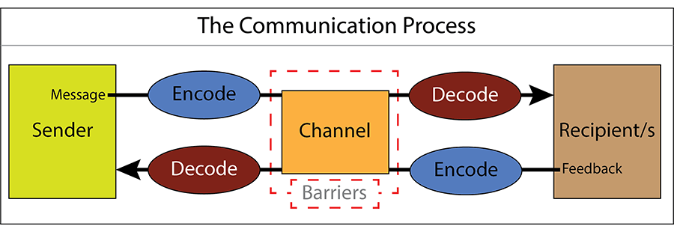

Communication Channels
Communication channels is the term given to the way in which we communicate. It is therefore the method used to transmit our message to a recipient, or to receive a message from someone else.
There are multiple communication channels available to us today. These include face-to-face conversations, telephone calls, text messages, email, the Internet (including social media such as Facebook and Twitter), radio and TV, written letters, brochures and reports.
Choosing an appropriate communication channel is vital for effective communication. Each communication channel has different strengths and weaknesses.
For example, broadcasting news of an upcoming event via a written letter might convey the message clearly to one or two individuals. It will not, however, be a time- or cost-effective way to broadcast the message to a large number of people. On the other hand, conveying complex, technical information is easier via a printed document than a spoken message. The recipients are able to assimilate the information at their own pace and revisit anything that they do not fully understand.
Written communication is also useful as a way of recording what has been said, for example by taking minutes in a meeting.

Encoding Messages
All messages must be encoded into a form that can be conveyed by the communication channel chosen for the message.
We all do this every day when transferring abstract thoughts into spoken words or a written form. However, other communication channels require different forms of encoding, e.g. text written for a report will not work well if broadcast via a radio programme, and the short, abbreviated text used in text messages would be inappropriate in a letter or in speech.
Complex data may be best communicated using a graph, chart or other visualisation.
Effective communicators encode their messages so that they fit both the channel and the intended audience. They use appropriate language, conveying the information simply and clearly. They also anticipate and eliminate likely causes of confusion and misunderstanding. They are generally aware of the recipients’ experience in decoding similar communications.
Successful encoding of messages for the audience and channel is a vital skill in effective communication.

Decoding Messages
Once received, the recipient needs to decode the message. Successful decoding is also a vital communication skill.
People will decode and understand messages in different ways.
This will depend on their experience and understanding of the context of the message, how well they know the sender, their psychological state and how they feel, and the time and place of receipt. They may also be affected by any Barriers to Communication which might be present.
There are therefore a wide range of factors that will affect decoding and understanding.
Successful communicators understand how the message will be decoded, and anticipate and remove as many as possible of the potential sources of misunderstanding.

Feedback
The final part of a communication is feedback: the recipient lets the sender know that they have received and understood the message.
Recipients of messages are likely to provide feedback on how they have understood the messages through both verbal and non-verbal reactions. Effective communicators pay close attention to this feedback as it is the only way to assess whether the message has been understood as intended, and it allows any confusion to be corrected.
Bear in mind that the extent and form of feedback will vary with the communication channel. Feedback during a face-to-face or telephone conversation will be immediate and direct, whilst feedback to messages conveyed via TV or radio will be indirect and may be delayed, or even conveyed through other media such as the Internet.
Effective communicators pay close attention to this feedback as it is the only way to assess whether the message has been understood as intended, and it allows any confusion to be corrected.

Elements of Communication

Effective communication skills are critical for success in nearly any profession. Successful professionals know the importance of communication. They understand the process and how, if correctly used, it will help them be more successful on and off the job.

Here are 7 elements that are essential to successful communication.

1. Sender
- The sender is the person who is trying to communicate a message.
- The sender wants the other person to receive and understand his/her message. The intent of the message is usually to get the other person(s) to do or understand something.
Unfortunately, in the transference of information, the other person(s) may not understand the message the way the sender intended. In fact, it is not uncommon for the other person(s) to respond in some affirmative manner communicating the message was received. This does not mean the message was understood the way the sender intended.

2. Receiver
- The receiver is the recipient of the message and must translate the words into thoughts, process the thoughts, and determine how to respond to the sender.
- The challenge is that since the receiver’s education and experience may be very different from the sender, words often have different meanings.

3. Message
While you may carefully choose the words to speak, words alone represent a small percentage of what is received by the other person. In fact, according to the literature, words carry the least value in the message.
- Hence, what is said is not nearly as communicative as body language and voice inflection. Even when no words are spoken, communication is taking place. If a person frowns, does not make eye contact, or looks at his/her watch a message is being sent…and it may not be the intended message.
- Consequently, it makes sense to pay attention to body language and voice inflection. This takes more than casual watching and listening. It takes our full attention to be most effective.
- An effective message is one where there is congruency, or agreement, between the words, meaning, and emotion. Body language and voice inflection are essential in achieving congruency.

4. Channel
- Channel is the medium used by the sender to send the message to the receiver. This may be in-person, via telephone, e-mail, text message, written correspondence or a third-party.
- An important point to remember is that when communication is only verbal the most important element of communication body language is left out. If the communication is written, then both body language and voice inflection are left out.
- Therefore, depending on the nature of the message to be sent, a sender will want to consider which medium to use. More critical messages may require face-to-face meetings, while less critical messages may be appropriately sent via a verbal or written message.

5. Noise
- Noise refers to interference that takes place during the communication process. Both the sender and receiver may be distracted by noise. Noise may come from internal (thoughts, emotions, etc.) or external sources (radios, other conversations, etc.).
- When encountering a noise, take steps to reduce the distraction. If the noise is internal, take some time to refocus. Taking several deeps breathes can help. Excusing yourself to go get a drink of water may be the mental break needed to clear the mind.
- If the noise is external, then try to find a quieter location for the meeting. If necessary, consider rescheduling the meeting for a time when there are fewer distractions.

6. Feedback
Feedback is the process of determining if the message has been properly received. This can be initiated by the sender or receiver. The sender, for example, may ask the receiver to repeat the message to confirm that the message was received as intended. On the other hand, a good listener will provide feedback to confirm that he/she correctly received the message.
Feedback may occur in four ways.
- First, and probably most common, is paraphrasing. Paraphrasing is reciting back what the other person said in your own words.
- The second is summarizing. This involves making a brief statement of the key points and feelings expressed by the other person.
- The third is to reflect the feelings. The focus is not so much on the message as the emotions behind the message. This is often an effective way to reflect empathy.
- The fourth way is to reflect meaning. The focus of this type of feedback is to identify the meaning being expressed by the other person. On occasion, a person says one thing, but it carries a different meaning.

7. Context
Context is another way of taking into consideration the setting. Examples of context include:
- What is going through the other person’s mind when you show up? Did they just have a blow-up with an employee or customer?
- What is the environment like? Is it noisy? Are there customers standing around?
- What was the nature of the last contact and how did that go?
- What cultural factors should be considered?
- Are there notes or helpful information from the person who took the initial call?
Barriers of Communication
Communication barriers can be defined as obstacles that one may face when attempting to effectively communicate with another person. These barriers can be anything that can misrepresent and/or avert someone during the communication process. This process involves a sender, receiver, and message.
Physical barriers – These barriers are environmental challenges people face during communication due to their surroundings.
Emotional barriers – This barrier can stem from a person’s existing feelings toward a subject or person(s) involved in the communication process.
Cultural barriers – These barriers derive from differences in a variety of categories, such as religion, language, traditions, and power distance.
Cognitive barriers – Cognitive barriers are a combination of emotional and cultural barriers, such as word connotation affecting the message during the communication process.
Systematic barriers – These barriers stem from a lack of structure in an environment, often seen in workplaces where roles are not clearly assigned or vocalized.
Physical Barriers of Communication
Physical barriers of communication can most often pertain to geographic distance between sender and receiver. When face-to-face communication is limited, the communicators must rely solely on verbal communication. Nonverbal communication makes up a large amount of our everyday communication. Without the ability to nonverbally communicate due to geographical location, a physical barrier is created in the communication process.

Other common, everyday physical barriers are often referred to as noise in the communication process. Noise could be traffic whizzing by or other conversations happening during the time that the communication is taking place. Something as simple as a cell phone dying mid-call is considered a physical barrier because the communication has been severed by an outside source.
Physical Barrier
Mark was attending a staff meeting in an auditorium. The speaker was using a microphone to present information. However, at certain points of her speech, the microphone kept creating a loud ringing sound, and Mark was unable to hear what she was saying. This is an example of a physical barrier. The noise from the microphone interrupted the communication process.

Emotional Barriers of Communication
Emotional barriers of communication, or psychological barriers, could be seen in both the sender and receiver. These barriers are created from a multitude of things, including but not limited to the following: a person’s ego, prejudice, existing feelings toward a person, self-image, open/closed-minded mentality, status (often seen in workplace conflict), and interest.

These barriers could arise from anticipatory feelings or problems that stem from a previous experience with the person, which could be a result of differing communication styles, miscommunication, a person’s inability to listen, or their ability to effectively communicate a message. In order for effective communication to take place, both the sender and receiver must be open to the message. Emotional barriers often get in the way of the channel of communication. Emotional distress can lead to misunderstandings or a person’s inability to actively listen. These barriers often arise in stressful situations and are often seen in the workplace.

Cultural Barriers of Communication
Culture can be defined as a person’s way of life, or a code to which they live by. Cultural barriers of communication can stem from a number of cultural differences, such as language, status differences, gender roles, and body language. Various aspects of cultural barriers can be described as follows:

Language is the most obvious cultural barrier. Not only do language barriers encompass totally different languages, but they also include the lingo in which one uses in specific workplace environments. For example, a person familiar with technology would recognize basic acronyms, such as PDF or JPG. However, to a person that knows very little about digital documents, this would be a foreign language.
Gender barriers can best be defined as the differences between women and men in terms of communication style. For example, women prefer to meet face-to-face because they value nonverbal cues more than men. A physical separation during communication could pose conflict for women during the communication process.
Body language is a broad term, and large aspects of it are similar across cultures. However, some aspects, such as eye contact, vary from culture to culture. For instance, in China they view eye contact with an elder to be disrespectful. In America, however, eye contact is a sign of respect and trustworthiness.
Status is the way in which the people of a culture value one another. For example, high power distance cultures believe that respect is automatically given based on age, sex, and rank in the workplace; while a low power distance culture believes that respect must be earned and is not given solely based on status.
Cognitive Barriers of Communication
Cognitive barriers of communication can be defined as the differences in which a person perceives information during the communication process. This could include the following: selective perception, information overload, filtering, and denotation vs. Connotation.

Selective perception is when a person sifts through information and selects what they want to see or hear. Filtering is cautiously withholding information in anticipation for how a person will respond. Information overload refers to an abundance of information trying to be processed and interpreted at once. Denotation refers to the dictionary definition of a word, while connotation refers to how a culture uses a specific word.

Systematic Barriers of Communication
Systematic, or structural barriers to communication, can be defined as a barrier that one encounters during the communication process when there is a lack of credibility or familiarity with the source or information. Sarcasm or irony are both examples of a systematic barrier disrupting the communication process. A common example of this is when someone tells a joke and the other person doesn’t understand it. Lack of familiarity with the sender and/or their humor can lead to misunderstanding.

Another example of a systematic barrier is gossip. Gathering information through the “grapevine” is not always the most reliable source. That is why it is best to hear things “straight from the horse’s mouth” in order to avoid systematic barriers in communication.

Communication Barriers Examples
The following are communication barrier examples organized by type:

Skip to content

The 7 C’s of Communication
The seven C’s of communication is a list of principles for written and spoken communications to ensure that they are effective. The seven C’s are: clear, correct, complete, concrete, concise, considered and courteous.

The 7 C’s of Communication
The seven C’s of communication is a list of principles that you should ensure all of your communications adhere to. Their purpose is to help ensure that the person you’re communicating with hears what you’re trying to say. The seven C’s are: clear, correct, complete, concrete, concise, considered and courteous.
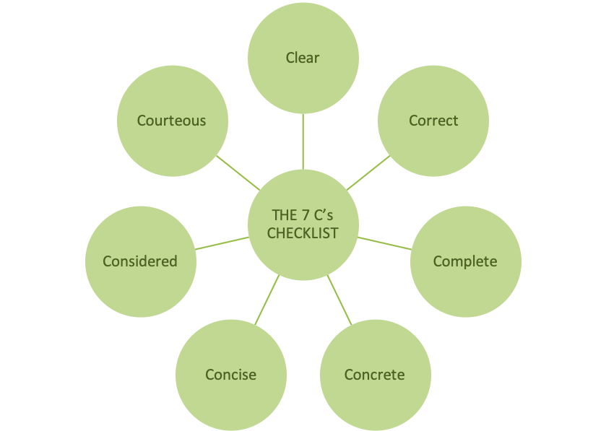

Clear
There are several stages to clarity.
Firstly, it’s important to be clear about the purpose of the message you’re delivering. The recipient should be made aware of why they are receiving the message and what you’re trying to achieve by delivering it. If there are multiple goals, each should be laid out separately.
Secondly, it’s essential that the content of the communication is itself clear. You should avoid jargon, use simple language, use simple structures and focus on the core points of your message.

Correct
It’s essential that both the factual information and the language and grammar you use are correct. If your audience spots errors in either, they will be distracted and your credibility will be greatly reduced. This will reduce the effectiveness of your communication.
Some communications simply must be correct, clear and concise.

Complete
Completeness is often one of the most important of the 7 Cs of communication.
When creating a message, it’s important to give the recipient all of the information they need to follow your line of reasoning and to reach the same conclusions you have. This level of detail will be different in different situations, and you should adjust your communications accordingly.
In addition, you should make things as easy as possible for the recipient. For example, if you are issuing a “call to action”, provide explicit guidance on that action. Increasingly it’s common to include things like hyperlinks in written communications or to attach FAQs, both of which help audiences access a complete set of information while also ensuring that core communications focus on core messages.

Concrete
When shaping your communication you must ensure that you are specific and that the logic and messages that you’re using fit together, build on each other and support each other. Your arguments should be based on solid facts and opinions from credible sources and you should share irrefutable data to support your argument.
It may be important to help bring the solid nature of what you’ve created to life for your audience through examples that show the relevance of your messages for them as individuals.

Concise
When communicating messages of this nature it’s important to stick to the point and keep your messages short and simple. Don’t use 10 words if you can use five. Don’t repeat your messages.
The more you say, the more risk there is of confusion. Avoid that risk by focusing solely on the key points you need to deliver.

Courteous
People are not always courteous.
You can increase the effectiveness of your communications by being polite and showing your audience that you respect them. Your messages should be friendly, professional, considerate, respectful, open and honest.
To help ensure you are courteous, you should always use some empathy and consider your messages from the point of view of the audience.

Considered & Coherent
The last of the 7 Cs of communication is considered or coherent. If your communications are not coherent they will not be effective. To help make sure your communications are considered and coherent you should have a logical flow and your style, tone and language should be consistent throughout.
In addition to making sure that each communication you issue is coherent within itself, you should also ensure consistency of message when delivering multiple communications.

